

INFORMATION GOVERNANCE TRAINING TOOL
ORGANISATION REGISTRATION AND TIPS FOR IMPLEMENTATION

Introduction

- Organisations that process personal information have legal, moral and often ethical obligations to take appropriate technical and organisational measures against unauthorised or unlawful processing, accidental loss, destruction or damage of personal data. Staff education, awareness and training are key elements to meeting these obligations.

- Information Governance (IG) training and awareness was a requirement of the Cabinet Office Data Handling Review 2008 and lack of IG training provision was a concern included in the Care Quality Commission study of IG processes in 2009. In September 2011 a directive from NHS CE and the Information Commissioner jointly recommended that at all NHS organisations (and others with access to NHS patient information) should take ensure all staff take appropriate IG training annually.

What is the Information Governance Training Tool (IGTT)?

- IGTT is a free online training resource (accessible via the internet). The system is primarily designed to allow each staff member to open an account linked to their employing organisation, complete individual training and print out certificate(s) with their registered name. Training progress is recorded and can be accessed by the Organisation’s Administrator. Instead of individual on-line accounts for each member of staff, organisations may download material for in-house “face to face” training and maintain their own training records. Organisations wishing to use IGTT are expected to resolve local issues (e.g. assist staff who are unused to computers or have difficulty using computer based learning).

- The training is set at three levels (Introductory, Foundation and Practitioner). Each organisation should decide which module(s) is/are appropriate to meet or support the training needs of individual staff (or staff group) and the organisation’s obligations (see “Recommending Appropriate Modules to Staff”).

- At the time of writing, the modules cover:

- Confidentiality & Caldicott (4 resources)
- Embedding informatics in the NHS (3 resources)
- Independents / Third Sector (2 resources)
- Information Governance and IG Management (5 resources)
- Information Governance for NHS CFH Staff (2 resources)
- Information Risk Management (3 resources)
- Information Security (5 resources)
- Records Management (5 resources)

- If you want your organisation to use IGTT please provide details using the form at the end of this guidance and send it to the national helpdesk. Applications are collated to monitor the uptake of users and gauge performance, reliability and resilience of the training system resources.

Implementing IGTT in Your Organisation - Tips

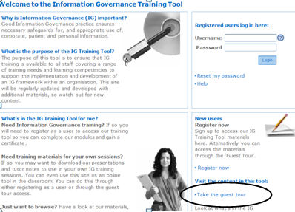
- Before implementing IGTT across your organisation, there are some planning considerations to make the process and management efficient and simple.

- Guest Tour. Look through a module using the “guest tour” to find out if your internet speed and computer is adequate and on-line training is what you want for your organisation. The tour is available from the IGTT Homepage:

https://www.igte-learning.connectingforhealth.nhs.uk/igte/index.cfm? > “Take the guest tour”

- Staff IT Skills. Consider the need for basic IT training for staff members who have minimal IT skills or may want other assistance.

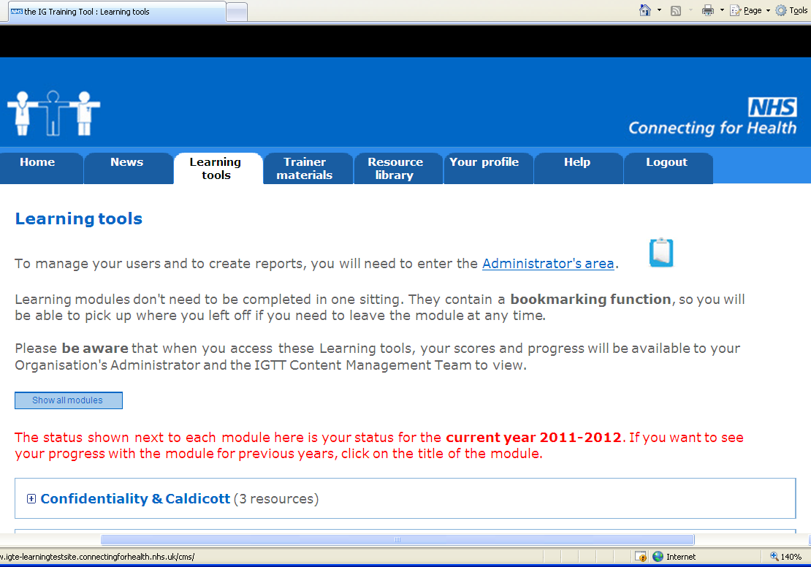
- Administration. Administrator accounts have access to additional parts of the site to manage user accounts and to run reports (see screen shot). Each organisation should have an Organisation Administrator (OA) e.g. IG Manager, Training Manager, Practice Manager. Knowledge of spreadsheets will be an advantage if there are a high number of users. The Administrator’s details will be made visible on the “Learning Tools” page so that local staff members know who they should contact for immediate assistance. Other accounts (Support Administrators) which mirror OA accounts can set up by the OA.

- Organisation Code and Title. The organisation’s code (provided by NHSCFH) and title must be correctly listed on IGTT and staff must be made aware of the code to use before they attempt to self register. Note: if a staff member inputs the wrong organisation code they will appear on the reports of the wrong organisation he/she has registered against). To resolve this, the user will need to log in and change the organisation recorded on his/her ‘Your Profile’ page.

- Registration and User Names. Accounts may be registered with or without an e-mail address (not all e-mail domains are accepted – see below). Training progress is tracked by ‘user name’. If an e-mail address is entered on registration, then this is the ‘user name’ and cannot be used by another person.

- If a person registers without an e-mail address the ‘user name’ may have been used by another person. In this case digits will be automatically added to the username to make it unique e.g. Julie Smith may be allocated a user name of julie4.smith). Staff should be advised to remember or make a note of their unique user names as they tend to be forgotten. OAs can access user accounts to identify forgotten user names.

  - Registration with an E-Mail Address. The site is pre-set to allow registration of NHS work e-mail domains e.g. my.name@nhs.net and my.name@nhs.uk. These are usually less easily forgotten than an allocated user name (see above). If you have a company / organisation directory e-mail and staff individual e-mail addresses which you wish to use e.g. ‘my.name@myemployer.co.uk’ the domain such as ‘myemployer.co.uk’ can added by the national helpdesk (see contact details below) to facilitate this. Include this in your organisation’s request to use the IGTT. Note: for security reasons Yahoo, hotmail, tiscali, btconnect and other similar addresses cannot be used.

  - Registration of Users By Administrator. Only users who have their own unique e-mail address can be registered by administrators. This can be done one at a time or in ‘bulk’ by uploading a csv spreadsheet. Administrators cannot register users who do not have an e-mail address because the users will need to set up his/her own security question and answer on the registration screen. Before an Administrator registers staff, the staff should be informed that they will receive an automatic registration e-mail from the IGTT (if the e-mail does not arrive it may indicate the address is incorrect or the mail system has blocked the e-mail).

- Setting up ‘Organisational Departments’. Local Administrators can set up separate ‘Department \ Directorate \ Division’ for their organisation so that users choose their own work area. This allows an Administrator to sort staff training reports by department or site. An advantage of registering all users against the same organisation e.g. head office is that one administrator can manage staff located at different sites or branches. If a user is already registered on the system and you introduce this department option later, the next time they log in they will be prompted to select a department.

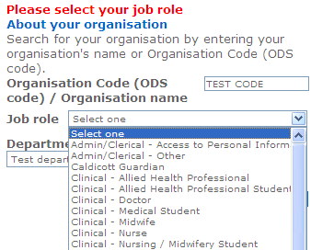
- Job Roles in IGTT. Each organisation “type” has a pre-set list of job roles (see screen shot). The list of job roles is limited to the main staff groups / roles. If a major staff group is missing you can request that this is added by contacting the national helpdesk, however, as this will affect ALL organisations of this type, the request may be declined. All modules visible and accessible, no matter which job role is selected by the user.

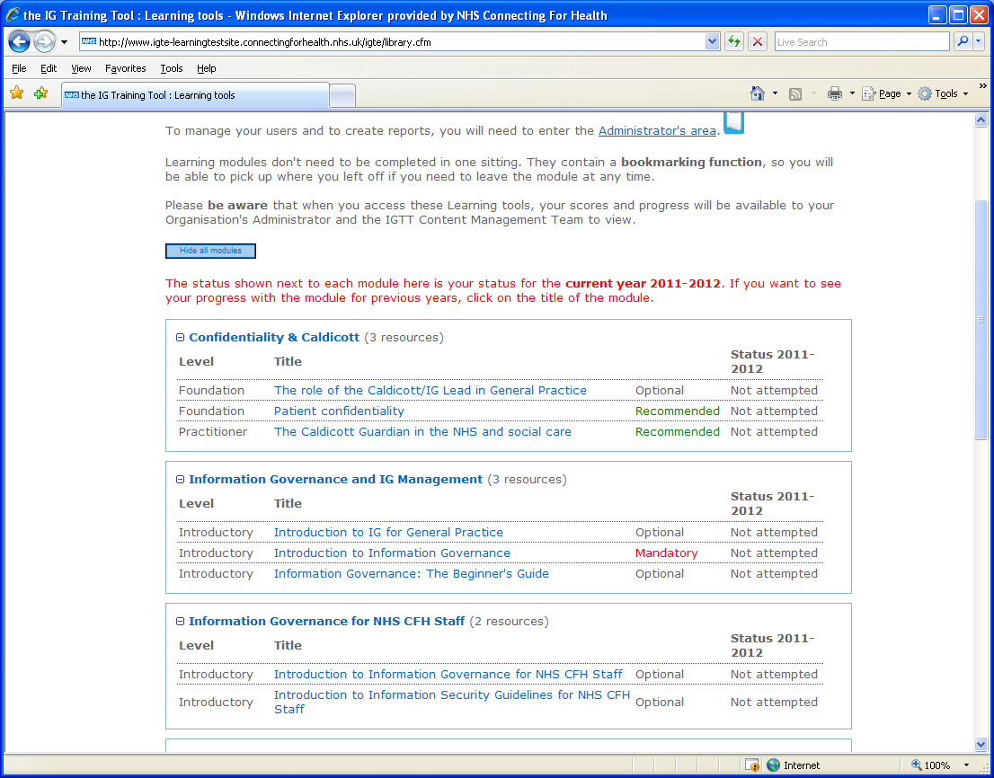
- Recommending Appropriate Modules to Staff. When staff log in they will see a list of all modules. Administrators can set the module status (‘recommended’, ‘optional’ or ‘mandatory’) to highlight the appropriate module(s) to the job role chosen by their users (see screen shot). The appropriate modules should be determined by the organisation.

- Providing Written Guidance for Staff. Staff should be provided with local guidance (preferably written) to which they can refer when needed. The guidance should include:

  - Who in the organisation to contact for advice and guidance (normally the administrator).
  - If the Administrator is registering users (using e-mail as user names) warn staff to expect a registration e-mail from the IGTT system which will include their user name, password and instructions.
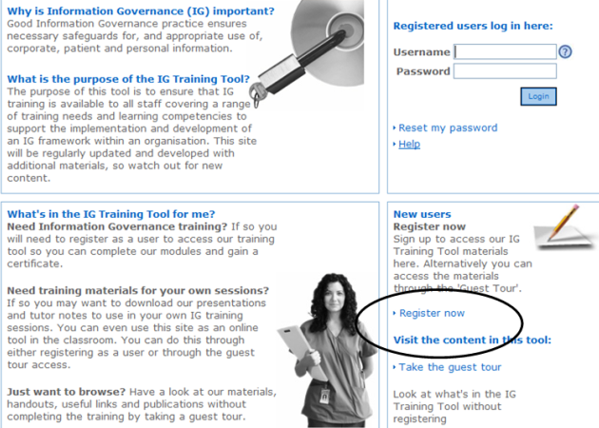
  - If staff are asked to self register (see screenshot):
- To register with or without an e-mail and the e-mail format to use (if applicable).
- The employing organisation’s code and title (as checked by the Administrator).
- The job role to choose.
- The ‘Department \ Directorate \ Division’ to select (set by the Administrator (if applicable))
- The address of the IGTT home page and the ‘Register now’ link:
http://www.igte-learning.connectingforhealth.nhs.uk/igte
  - Which module(s) to complete and how they are accessed (i.e. via the ‘Learning Tools’ tab).

Further Advice for Organisation Administrators

- The NHS IGTT Administrator’s Guide is downloadable from the website (you must be logged in as an Administrator); log into the IGTT > Go to ‘Learning tools’ tab > Click on ‘Administrator area’ link > Click on ‘Administrator Guide’.

National IG Training Tool Helpdesk

- In all correspondence please quote “IG Training Tool”.

Normal working hours: Weekdays

Email address: CFH.IG-trainingtoolhelpdesk@nhs.net

Information Governance Training Tool
Request for Organisation Account

Account Details
Full name, address (including postcode) of organisation.

The ODS Code issued by NHSCFH (if applicable).
Number of staff (to receive training per year).
The nature of the services provided (or supporting) health or social care
(this will determine the organisation type allocated to your organisation).
The name of the NHS organisation to which these services are currently or intended to be provided or supported.
The e-mail domain which will be used by staff is: (e.g. ‘my.name@myemployer.co.uk’) (if applicable).
The title, full name, telephone number, e-mail address and job role of the nominated Organisation Administrator
Any additional information which may assist creating your IGTT account

Please send completed forms to the IG Training Tool national helpdesk
CFH.IG-trainingtoolhelpdesk@nhs.net

The NHS Operating Framework 2010/2011 contains a requirement for NHS Trusts to provide annual basic IG training to staff using the Department of Health’s Information Governance Training Tool (IGTT).

